Bio 100 – Chapter 6 Quiz

- Please match the following words to their definition.
  - Energy _____
  - Calorie _____
  - Oxidation _____
  - Reduction _____
  - Entropy _____
  - Enthalpy _____
  - Free Energy _____
  - Activation Energy ____
  - Catalysts ____
  - Substrate ____
  - Active Site____
  - Inhibitors ____
  - Allosteric enzymes ____
  - Metabolism _____
- Compare and contrast kinetic energy and potential energy. ______________________________________________________________________________________________________________________________________________________________________________________________________________________________________________________
- How many calories are in a kilocalorie (kcal)?
  - 10
  - 100
  - 1000
  - 10000
  - 100000
- Fill in the blank. 1st Law of Thermodynamics states, “Energy cannot be _____________ or _____________.”
- Fill in the blank. 2nd Law of Thermodynamics states, “__________ is more likely than ___________.”
- Compare and contrast endergonic reactions vs exergonic reactions. Make sure to include whether the change in free energy is positive or negative. (Extra Credit) Give an example of a reaction in your own body that does both. ______________________________________________________________________________________________________________________________________________________________________________________________________________________________________________________
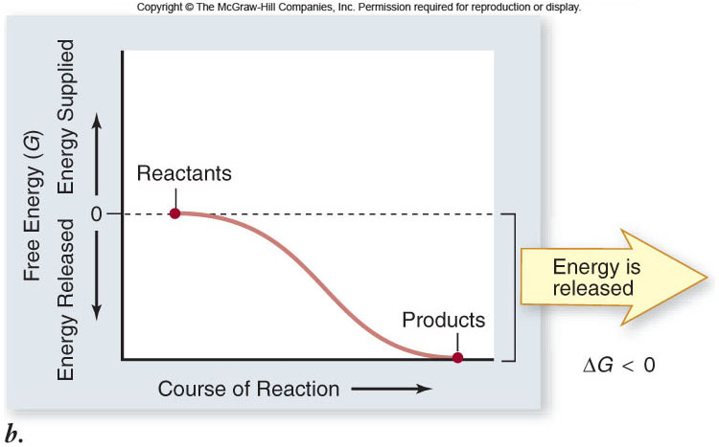
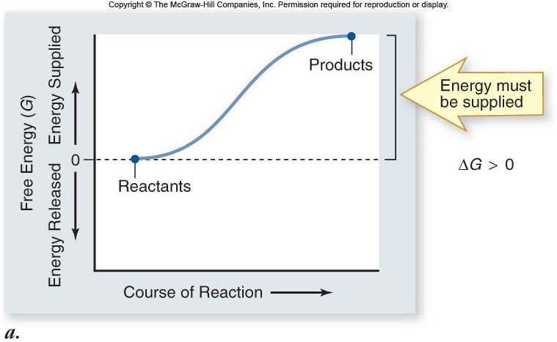
- Name the two reactions on the following graphs.

- How do catalyst work?
  - Higher the activation energy
  - Lower the activation energy
  - Allow less reactants needed
  - Allow more products needed
  - Lengthen the reaction
- Where does ATP store its energy?
  - Phosphate bonds
  - Sugar bonds
  - Lipid tails
  - Electrons
  - Protons
- Fill in the blank. Not all enzymes are ________, but most are.

- List three factors that affect enzymes’ function.
  - _________________________
  - _________________________
  - _________________________
- Compare and contrast competitive and noncompetitive inhibitors. Please be specific on where these bind. ______________________________________________________________________________________________________________________________________________________________________________________________________________________________________________________
- Compare and contrast anabolism and catabolism. Please include which one requires energy and which one releases energy. ______________________________________________________________________________________________________________________________________________________________________________________________________________________________________________________
- Sometimes enzymes need help. Please name the two ways enzymes can receive help.
  - _________________________
  - _________________________
- Please label which reaction is an example of a negative feedback loop and which one is an example of a positive feedback loop.
