Bio 160 Muscular System Exam
- Name the three types of muscle tissue.
  - ___________________
  - ___________________
  - ___________________
- What is the name of the connective tissue that separates muscles from each other?
  - Fascia
  - Periosteum
  - Epimysium
  - Perimysium
  - Endomysium
- Please name the layers of connective tissue from the deepest layer to the most superficial layer.
Muscle fiber: _______________ ____________________ _________________ ______________
- What kind of shape do muscle cells resemble?
  - Circle
  - Square
  - Cylinder
  - Polyhedron
  - Prism
- What causes the striations in skeletal music tissue?
  - Thick filaments
  - Thin filaments
  - Thick and thin filaments
  - Z line
  - H zone

- Please describe and draw the sarcomere. Make sure to include A bands, I bands, H zone, M Line, and Z line. You may use the drawn image to help you explain what a sarcomere is. __________________________________________________________________________________________________________________________________________________________________________________________________________________________________________
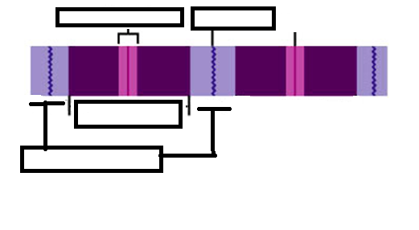
- In skeletal muscle, what neurotransmitter is released at the neuromuscular junction in order for a muscle to contract?
  - Acetylcholine
  - Acetylcholinesterase
  - Norepinephrine
  - Epinephrine
  - Dopamine
- What allows the muscle to relax after it has contracted?
  - Acetylcholine
  - Acetylcholinesterase
  - Norepinephrine
  - Epinephrine
  - Dopamine
- What is the name of the enzyme that breaks down ATP?
  - ATPase
  - ADPase
  - Acetylcholinesterase
  - Lipase
  - Amylase

- In your own words, please describe the sliding filament theory. What is the function of this process? ________________________________________________________________________________________________________________________________________________________________________________________________________________________________________________________________________________________________________________________
- What protein makes up the thick filaments?
  - Actin
  - Myosin
  - Tropomyosin
  - Troponin
  - Myothic
- What ion is released from the sarcoplasmic reticulum in order for a muscle to contract?
  - Sodium
  - Potassium
  - Calcium
  - Phosphate
  - Water
- What biochemical is responsible for regenerating ATP from ADP?
  - Creatine Phosphate
  - Norepinephrine
  - Epinephrine
  - Acetylcholine
  - Dopamine
- Short answer. What is the function of hemoglobin? _________________________________________________________

- Short answer. Where can I find myoglobin and what is the function? _________________________________________________________

- Short answer. Several hours after death, skeletal muscles go under partial contraction that fixes the joints, called rigor mortis. Why does this happen? __________________________________________________________________________________________________________________________________________________________________________________________________________________________________________
- What must muscles reach in order to contract?
  - Twitch
  - All or none response
  - Threshold stimulus
  - Myogram
  - Period of contraction

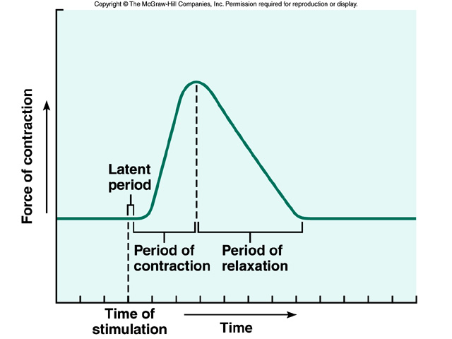
- Label. Please label this graph in order to explain what is happening at each point. Use the following words Period of relaxation, period of contraction, and latent period.
- What is it called when a contraction is sustained and lacks any relaxation?
  - Summation
  - Twitch
  - Tetanic Contraction
  - Muscle recruitments
  - Motor end plate
- What are skeletal muscle undergoing when you pick up an object that is heavier than what you thought? Why? __________________________________________________________________________________________________________________________________________________________________________________________________________________________________________
- Compare and contrast multiunit smooth muscle and visceral smooth muscle. __________________________________________________________________________________________________________________________________________________________________________________________________________________________________________
- What is the word for the wavelike motion that hollow organs do to move things along? For example, your small intestines moving food along.
  - Psoriasis
  - Peristalsis
  - Paralysis
  - Dialysis
  - Periosteum
- What is self-exciting and rhythmic?
  - Cardio
  - Cardiac muscle
  - Cardi B
  - Smooth muscle
  - Skeletal muscle
- What is one of the components in the heart that allows the heart to beat?
  - Intervertebral disks
  - Intercalated disks
  - Peristalsis
  - Calcium
  - The brain
- The relationship between the biceps brachii and triceps brachii are examples of ___________?
  - Prime mover
  - Synergists
  - Antagonists
  - Synchronized
  - Fire and gasoline

